**Project Report for Ecommerce Website**

**Website Description**

Our coursework project is a website based on the E-commerce platform, which deals in shoes.

This project accommodates two websites, the customer's view and staff view. The customer's website is the dominant website that exhibits a navigation bar containing various options such as home, categories, about, contact us, account search bar and a cart to give customers a quality experience during online shopping. Customer can explore the latest trend by using the explore button on the home page or searching for his desired product in the search bar. The customer can select a product from searched product recommendations from the products page. Then the customer is taken to the product page to get the detailed information regarding the selected product after that customer can add the product to cart or directly buy. Once the customer desires to complete purchasing customer has to login to his account, or new customer can create a new account. After login, the customer can add the product to the cart. The customer views the product and checkout by entering detail in the checkout page and message displays of order confirmation. Customer can look over the order status on the order page and check their profile on the profile page.

The content management system website (staff view) is the same as the customer website. It has different options where staff can manage orders and products.

**Website Design:**

Customer website contains eight pages:

* Home page
* Login Page
* Create Account Page
* Products Page
* Product Display
* Cart Page
* Checkout Info page
* Checkout Confirmation
* Profile Page
* Order Page
* About Page
* Contact Us Page

**Home page:**

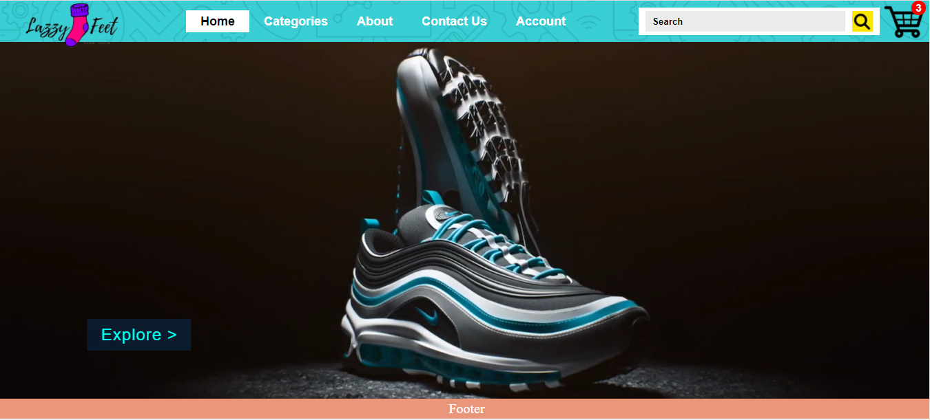

Home page of the website exhibits a video background with a explore button. The customer can explore the latest products through an explore button or search desire product on the search bar.

**Login page:**

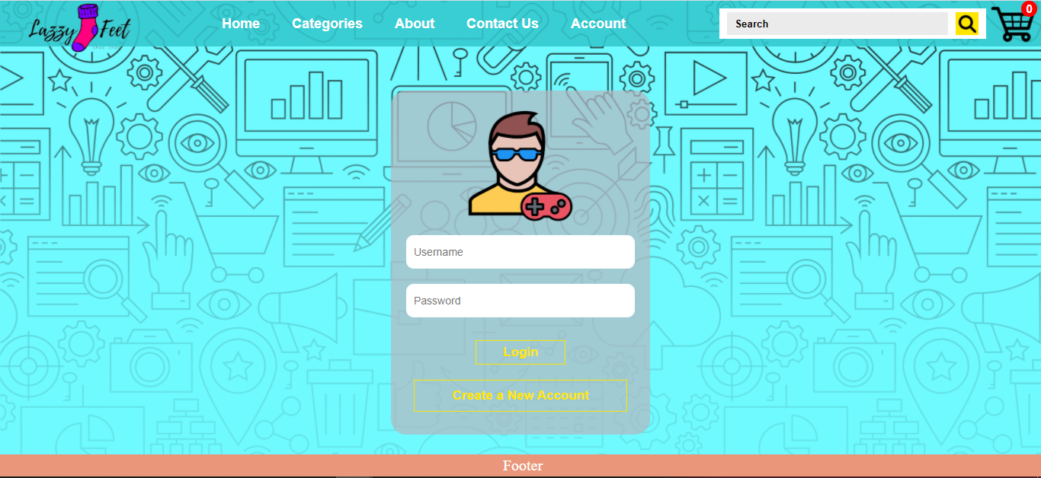

The login page accommodates a login form and a login staff and creates the account button at the page's centre. Registered customer can log in by entering ID and password, validated with stored ID and password in the MongoDB database. After validating, it takes the customer to the home page and creates a login cookie session with customer_id.

**Validations:**

* If the user forgets to fill any field, then a message exhibits "Please enter the fields".
* If the user is not registered, entered or entered an incorrect id, then a message exhibits "Email not recognised. Do you have an account?".
* If the user entered the correct id but incorrect password, then a message exhibits "Incorrect username or Password".

**Create Account page:**

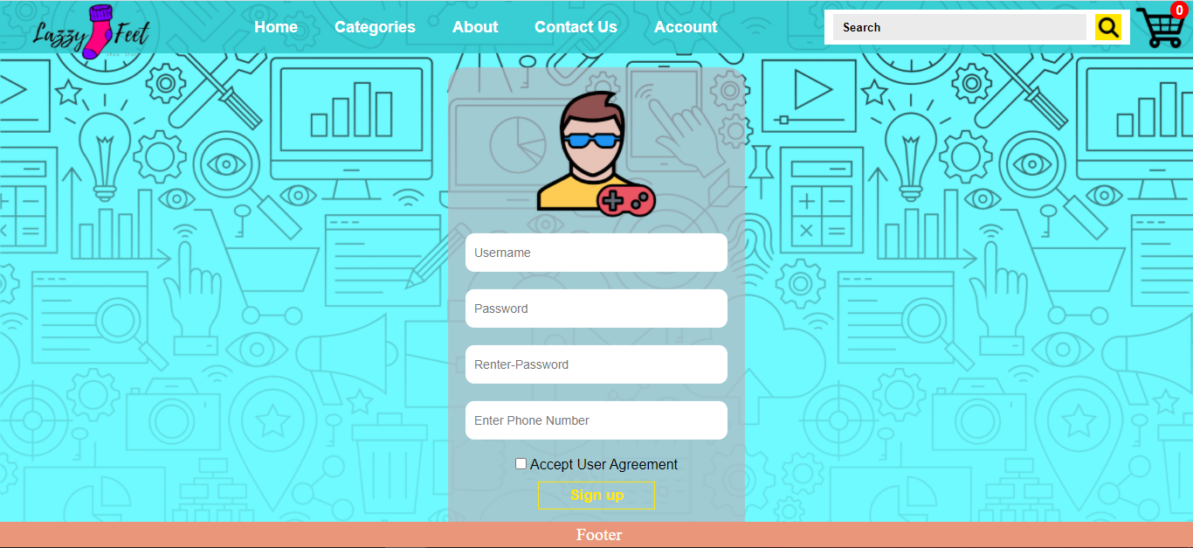

Create Account page accommodates a form and sign up button where the customer has to enter his email address, password and phone number. The user has to tick the Accept user agreement box for sign up. However, if the customer is a registered user, the user can go back to the login page by pressing the top-right corner's login button inside account option; once the user presses the sign up button, users data stored in MongoDB database. After storing it, it takes the customer to the home page and creates a login cookie session with customer_id.

**Validations:**

* If the user forgets to fill any field, then a message exhibits "Please enter the fields".
* When the user clicks on the password field, the password criteria box will be displayed and if the user input password in the wrong format, the message exhibits "Enter Password Under Certain criteria".
* If the user forgets to Accept the User Agreement, then a message exhibits "Please Accept User Agreement".
* If the user entered the correct id but incorrect password, then a message exhibits "Incorrect username or Password".

**Products Page:**

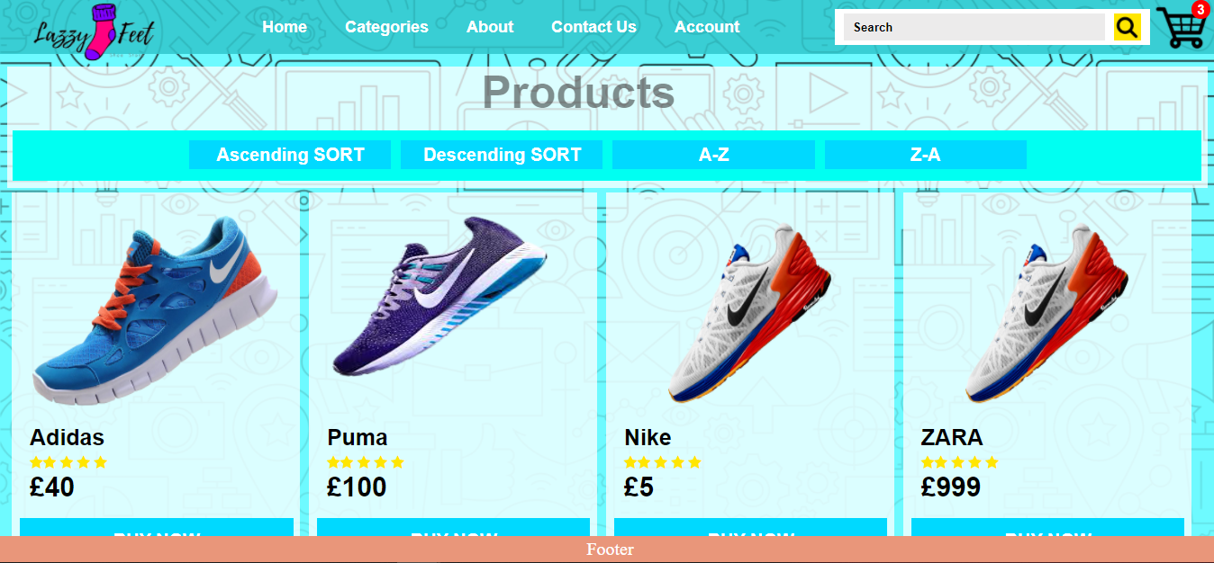

Products page accommodates product cards bottomed on search, which can be sort in multiple ways. Customer views the detailed product information by clicking on the desired product image; it stores product_id in session storage.

**Product Display Page:**

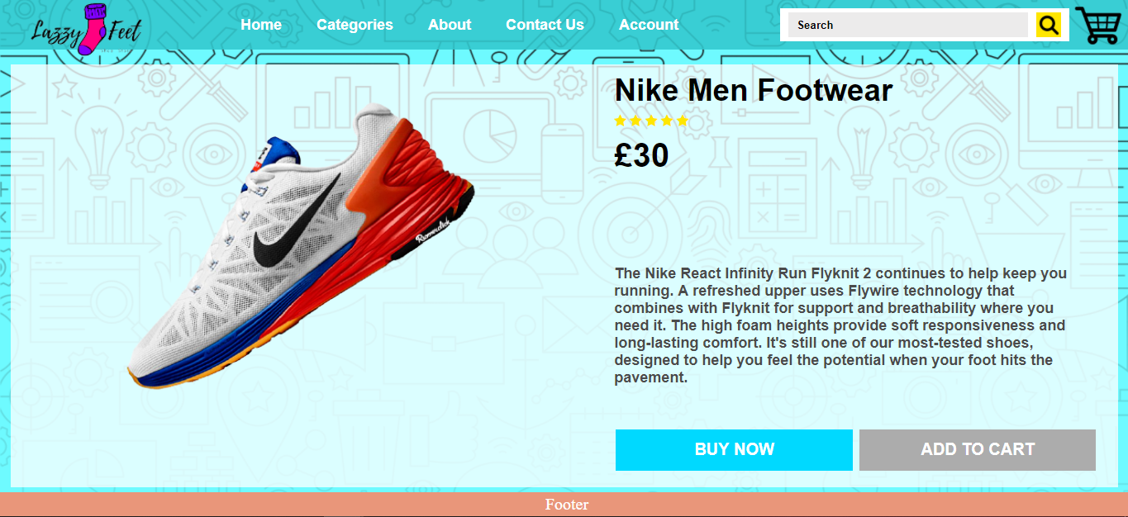

Products page accommodates product cards(Details and description regarding product) bottomed on selection, displayed by extracting product_id from session storage, stored by product page.

**Cart Page:**

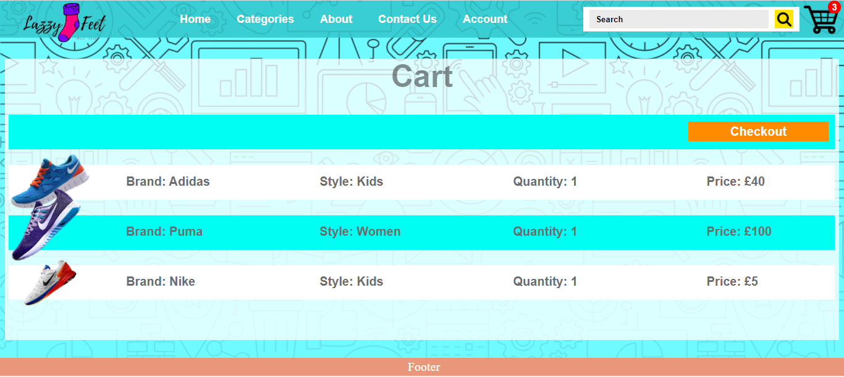

Cart page accommodates the customer's desired product and can be checkout by clicking the top-right button.

**Checkout Info Page:**

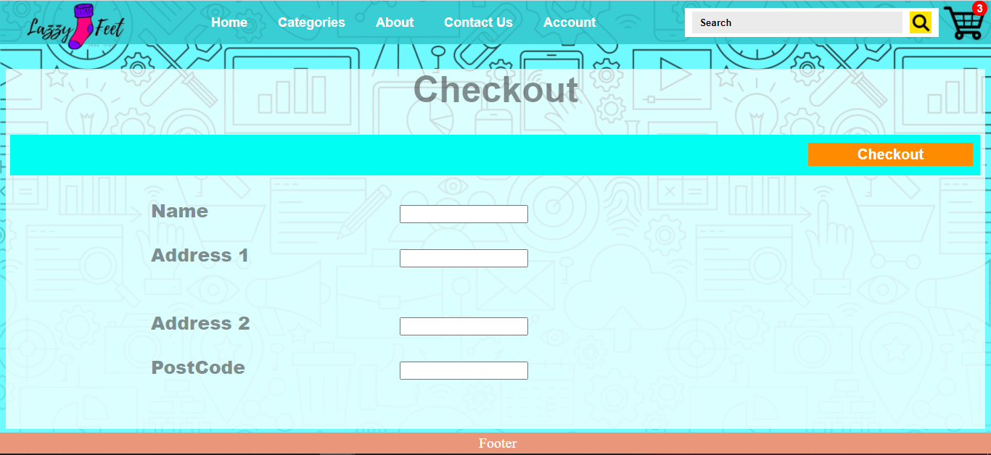

Checkout Info page accommodates a form where the customer has to enter their details.

**Checkout Confirmation Page:**

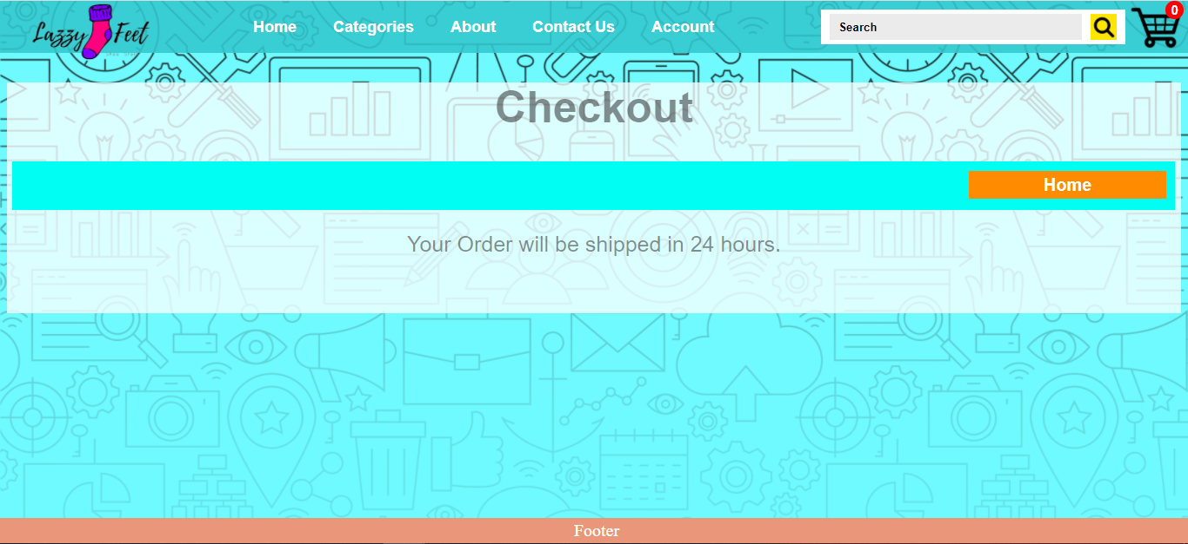

The Checkout Confirmation page exhibits an order confirmation message.

**Profile Page:**

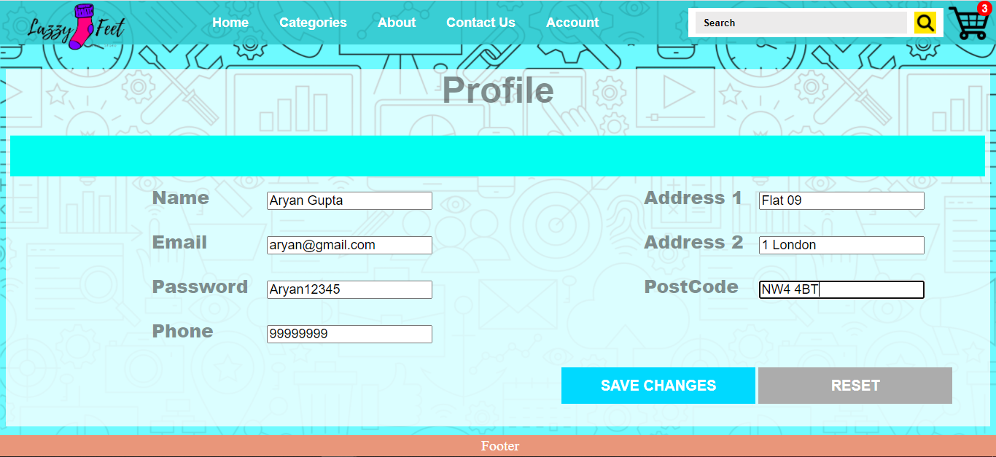

Profile page accommodates a form where the customer can change his details.

**Order Page:**

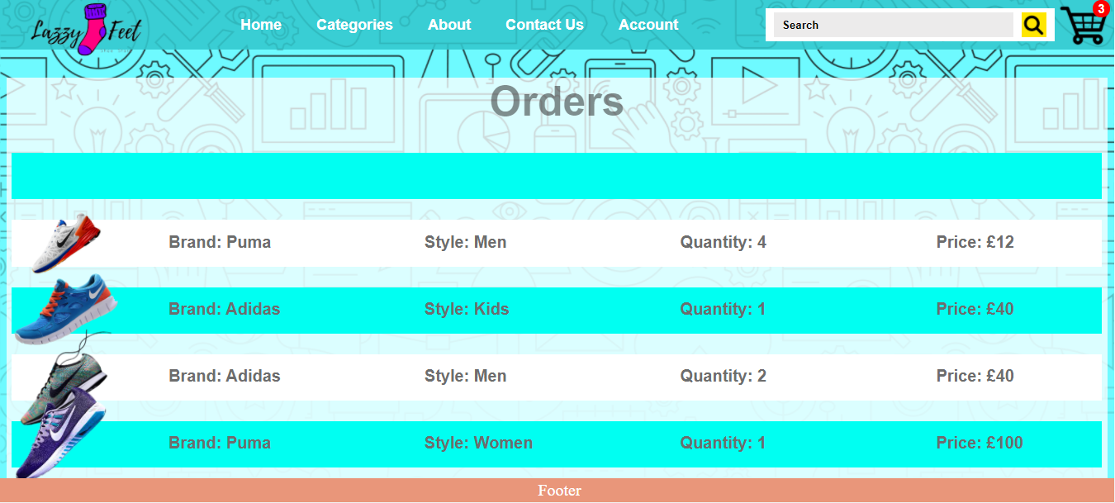

The order page exhibits the logged-in customer’s orders.

**Contact us:**

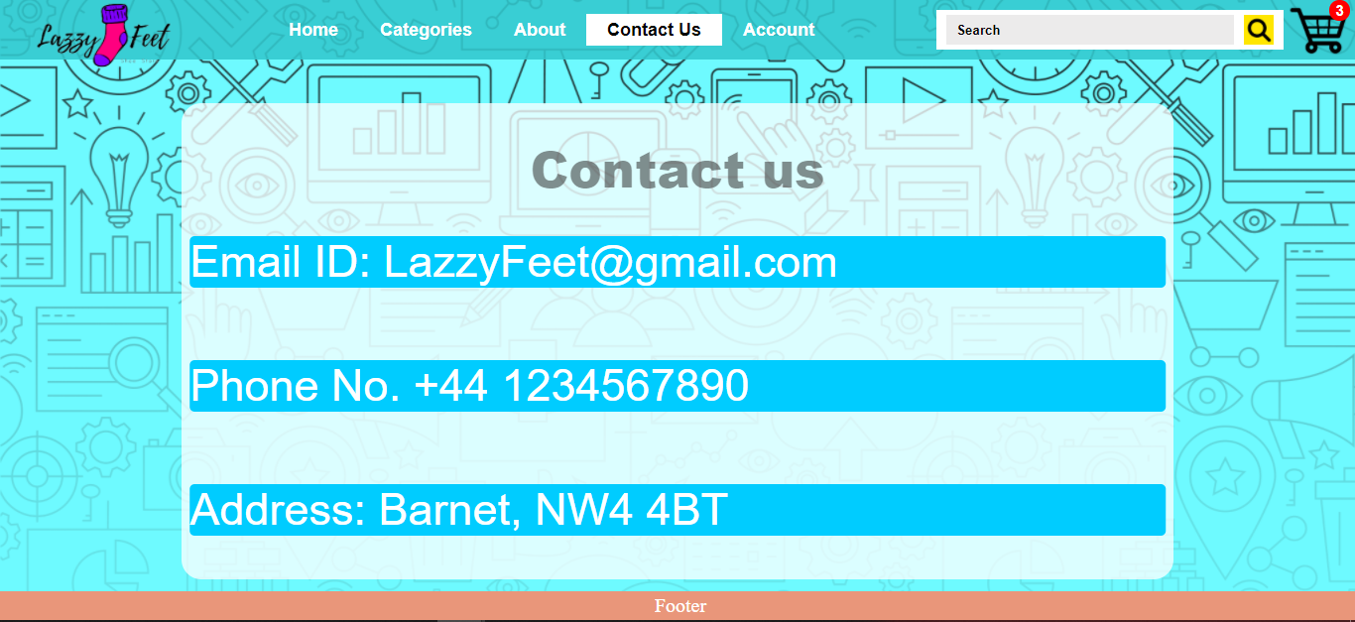

Contact us page accommodates company's contact information.

**About page:**

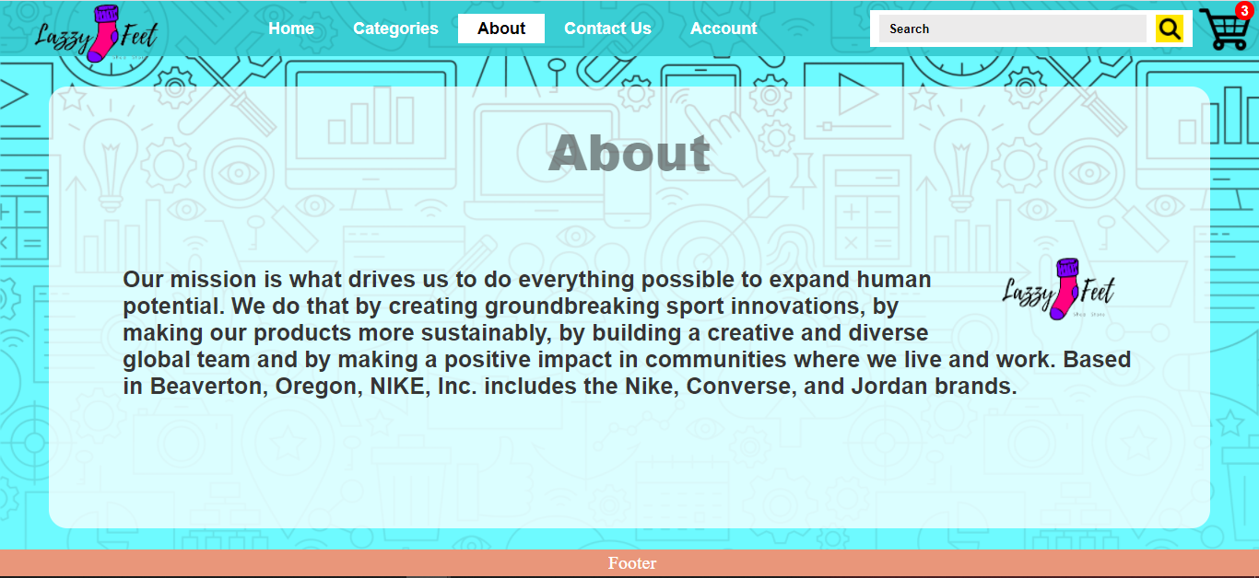

About page accommodate details and history of the company.

**Recommendations:**

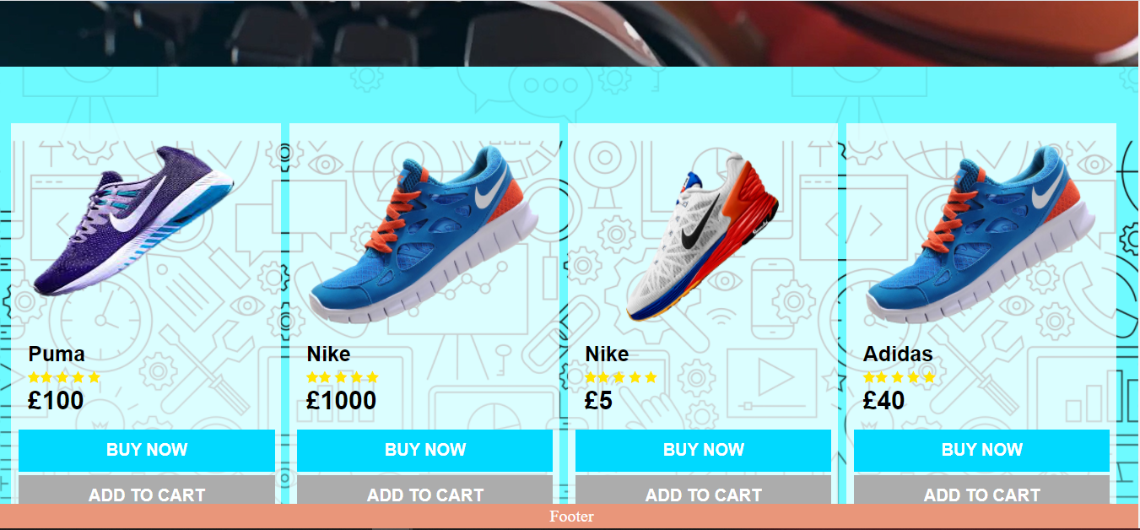

Customer tracking and recommendation are exhibited based on either logged in customer search or logout customer search.

Staff website contains six pages:

* Dashboard page
* Product Add
* Product Edit
* Customers Orders Page
* Help Page
* Login Page

**Dashboard Page:**

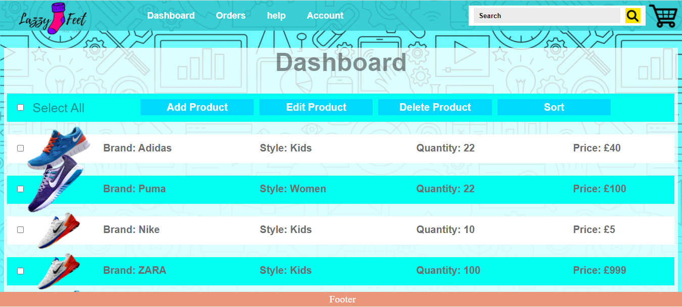

The dashboard page exhibits the products in the database, allowing them to add, modify, delete and sort.

**Add Product Page:**

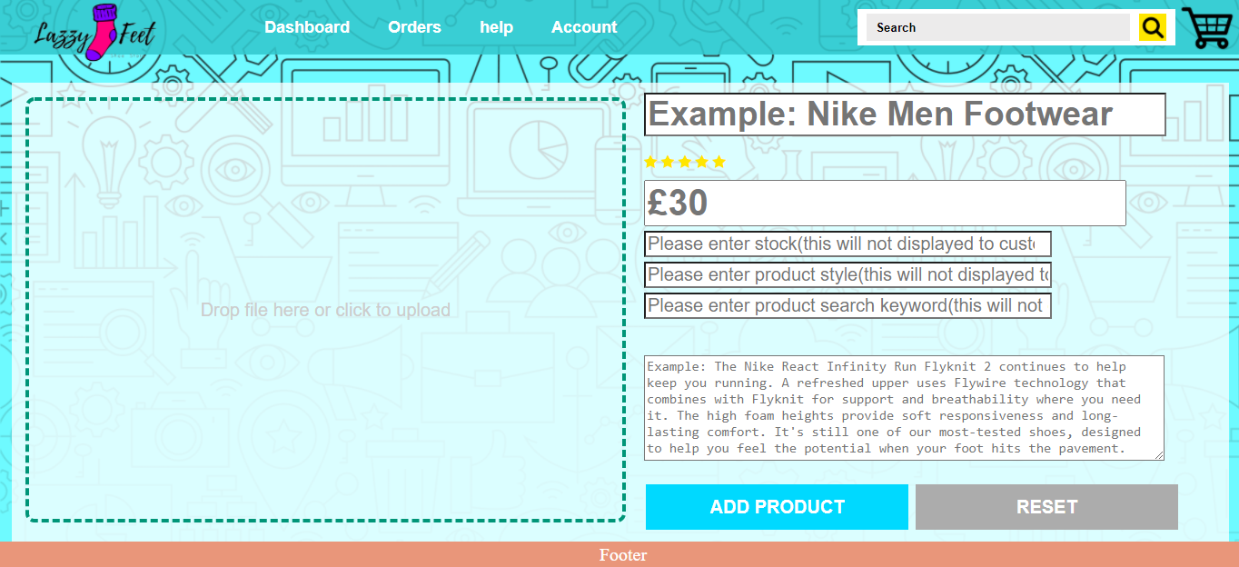

The product add page authorises adding the product and its details like a customer's view.

**Edit Page:**

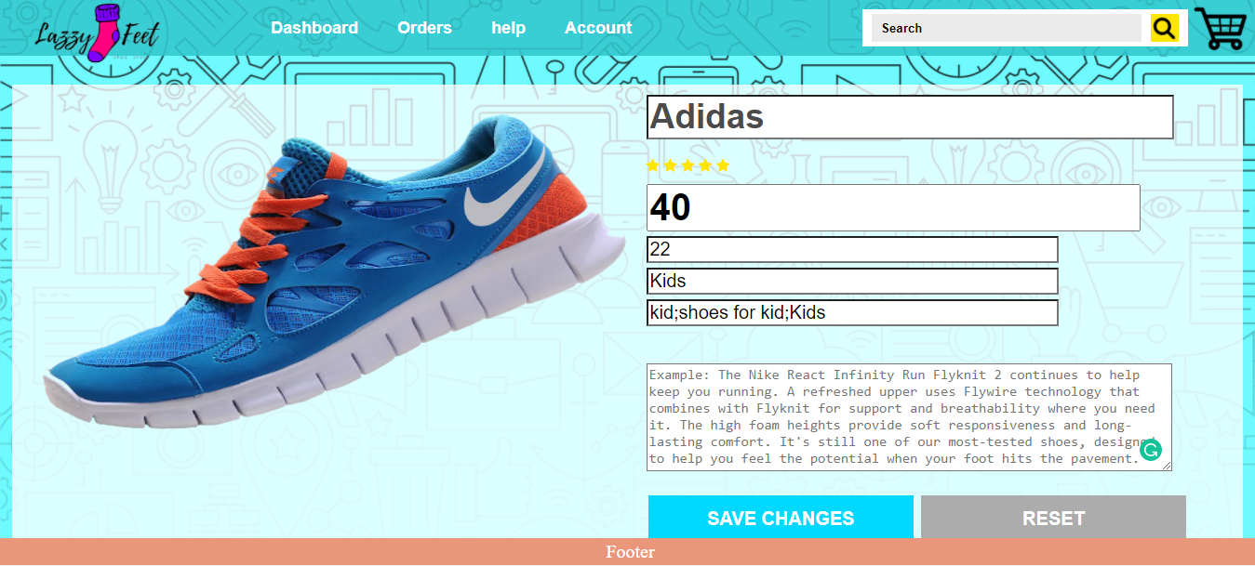The edit page authorises modifying the products' existing details on like a customer's view on the page.

**Orders Display Page:**

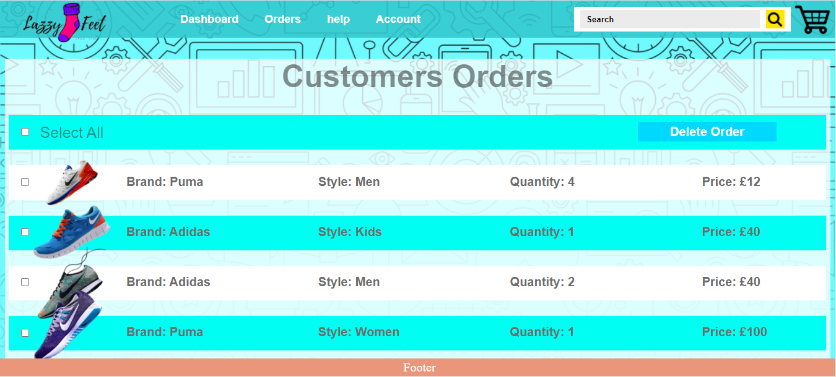

The order page exhibits the customers' orders through search bar beside, allowing staff to modify, delete, and view customer orders.

**Help Page:**

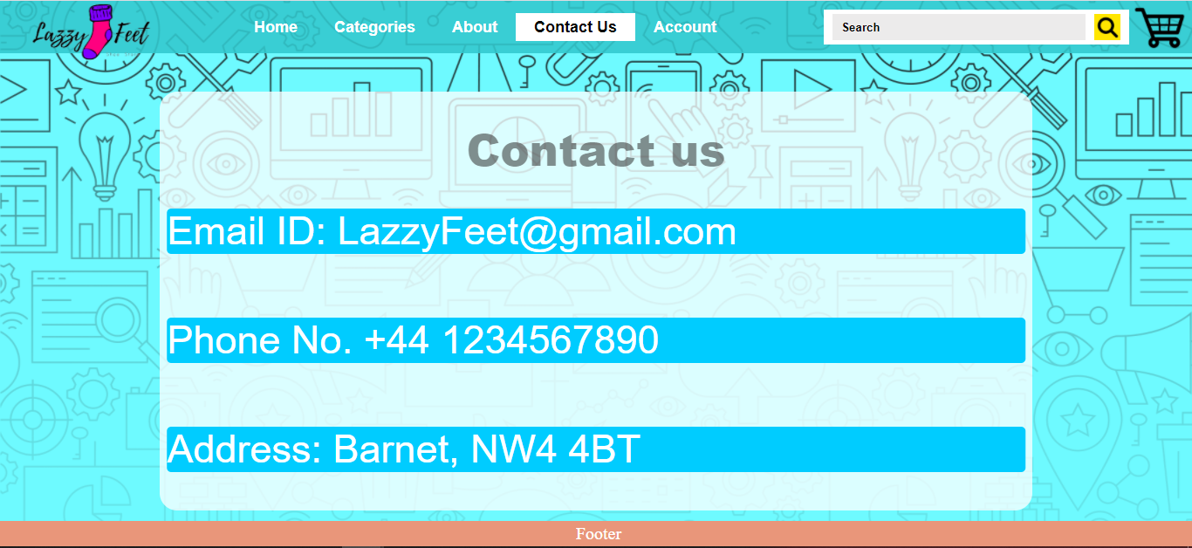

Help us page accommodates company's contact information for any assistance.

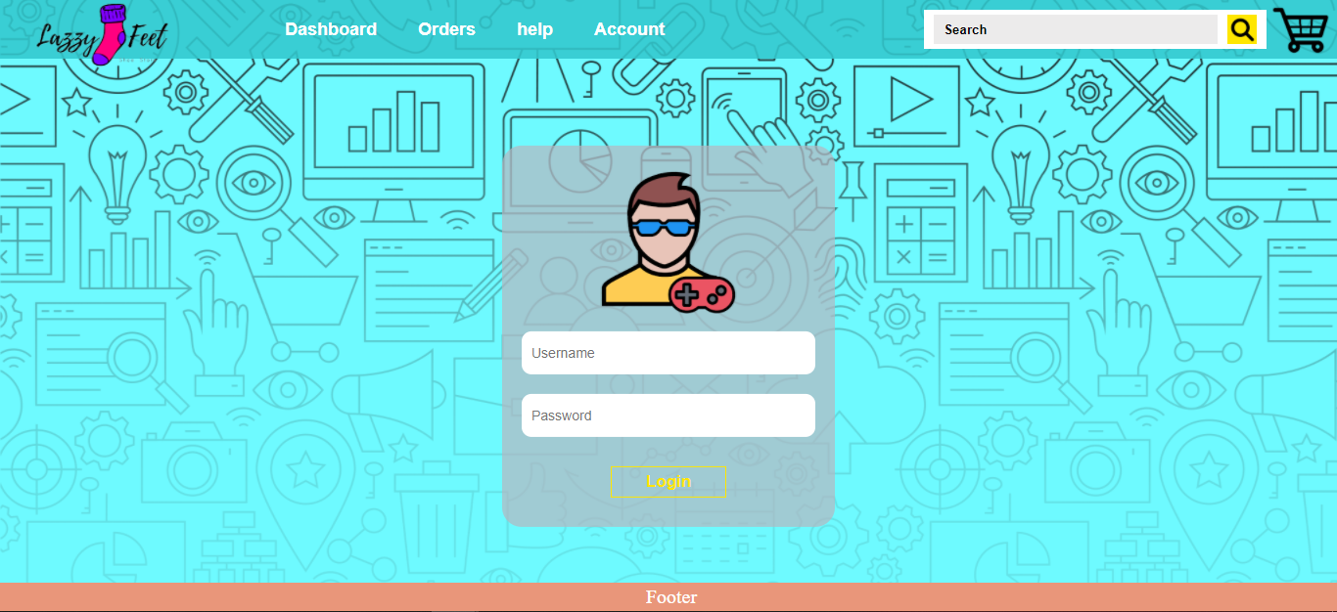

The Staff login page accommodates a login form and a login button. Staff can log in by entering ID and password, validated with stored ID and password in the MongoDB database. After validating, it takes the staff to the dashboard page and creates a login cookie session with staff email.

**Validations:**

* If the user forgets to fill any field, then a message exhibits "Please enter the fields".
* If the user is not registered, entered or entered an incorrect id, then a message exhibits "Email not recognised. Do you have an account?".
* If the user entered the correct id but incorrect password, then a message exhibits "Incorrect username or Password".

**Common.php:**

Common php file contains the Navigation bar and footer bar, which exhibits on every page by calling it. Common php sets up id and class for login session and class's active state.

**Common.js:**

Common js is responsible for logout session, which checks the session storage, based on that it exhibits Login/ Signup or Logout button.

**Security, Privacy & Legal issues**

**Security Issues**

These issues come in varieties for an E-commerce website. For example, SQL Injections, malware/attacks, Distributed denial of service & denial of service attacks, cross site scripting and so on. SQL injects work with code of the application to get into the database and corrupt its data. If the hacker is successful in this process, it will let them have full control of the website’s data to read, change, update, create, or remove information kept within the database. With Malware/attacks, hackers can get into the website without permission and they can cause a lot of problems. These include collecting customers’ private information, misusing them, displaying unnecessary ads, taking visitors to scam sites, automatically downloading harmful files, and using your website to attack other sites. Distributed denial of service attack is developed to take apart a website or make it slow by adding traffic to the server. These attacks can make your site go offline and fill your website up with viruses. There is a threat of cross-site scripting because it aims at placing code like JavaScript inside the output of the web application. This is risky because it controls the website's client-side scripts to run based on how the hacker controls it. This will allow them to take you to harmful sites, crash your website, and control customer sessions.

**Privacy issues**

Privacy concerns are vital because customers and business both can be affected by it. Customers decide to provide their details to a company’s website, and they expect them to keep the data safe and secured without being leaked, so if customer’s data gets out of hand by the sellers, the business can lose customers it can ruin their reputation. If it goes proceeds further, then legal actions may be taken to affect the company/website and ruin their whole brand. Many websites require individuals’ data to allow them to use their services. Sometimes they may mishandle personal data of customers, and it can cause serious problems. When you share your credit card details while purchasing products, you open doors for cybercriminals to take personal information to make a profit or execute harmful tasks on networks. Other privacy issues can involve identity theft and password because attackers are becoming smarter and finding new ways to discover patterns and recover passwords from stealing personal data for their use. Phishing is another method where anyone such as customers or sellers can be tricked into putting their card details to what they think it is a real website, but it is just there to misuse your data, download malware and send scam emails. There is a risk of bots that can be made to steal credit card information, and they can pretend to be someone else to use their bank card. Website cookies can be utilized to save your information to track an individual without their permission.

**Legal Issues**

Legal issues involve rules, laws and regulations that should not be breached otherwise. The consequences can have various effects such as damaged reputation, losing customers and paying penalties. Data protection is a must for a website to protect data to prevent cybercrimes and avoid fraud. If this law is breached, the company will have to pay a fine, usually, a small percentage of its revenue, which could rise if the data is breached several times. Defamation could be another problem because fraudsters, criminals, and hackers could ruin a company's reputation and website. This can straight away affect their business, loss of profits and customers. There is a risk of customers uploading illegal data on the website. There are problems moving data outside EU countries as it is illegal because the data protection rules are different in other countries, and they may not match with countries inside the EU.

**Resources:**

This page will be created using HTML, CSS, JavaScript, and PHP. The method of doing the website will be taken from W3School, YouTube, and Lecture Slides.

**Conclusion:**

We faced a few issues while completing this project. For example, we were using a university laptop that was continuously lagging. When I ran the visual studio code, it took a while because I had to wait to run my program. My hard drive wasn't working properly as it would disconnect on several occasions. The chrome would show error sometimes when I try running it. There was uniform lockdown due to pandemic that delayed the momentum of work, nevertheless, accomplish the task. At the same time, executing this project, this developed enthusiasm in connection to programming. There were long barriers while accomplishing the task rather than stepping backwards, we jumped over all the barriers by compilation of team members' contribution.